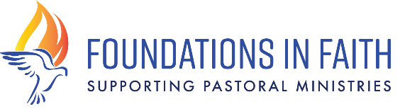
2020 St. John Paul II Fund
Innovate & Collaborate

CRITERIA TO APPLY: This grant is open to parishes and churches in the Diocese of Bridgeport who are committed to re-energizing their Faith Formation programs. Priority will be given to applications that reflect innovate approaches to Religious Education, Youth Ministry and underserved groups within the parish. Collective, collaborative project ideas that include youth in the process often yield the most creative approaches to “thinking outside the box”.
Grants may not be used towards a capital expense, church budget line items, paying down existing dept, or to donate to an organization or institution outside the parish.
*requests for technology must not exceed 30% of the grant request and must be tied to an innovative program described in this application.
GRANT SPECIFICS:
- Funding range: $1000-10,000 per parish
- A cap of 2 applications per parish; total grants awarded capped at $10,000 per parish
- The 2020 online application will be posted by February 15, 2020
- 2020 Applications and budgets are to be submitted online only and are due by April 2nd, 2020
- 2020 Applications will be reviewed by Foundations in Faith Grant Review Committee in May
- Recommendations by committee will be presented to the Foundations in Faith Board
- Funded projects announced and monies transferred to parishes in July-August, 2020
- All recipients attend the Annual Bishop’s Reception in the fall
- 2020 funded projects Mid-Year Reports are due January 2021 (Online form will be provided)
- 2020 funded project Final Reports due May, 2021 (Online form will be provided)
TECH TIPS: Foundations in Faith is using Google Forms for all applications. Here are some helpful tips:
- You will need to create a Google Account if you do not already have one. Click here
- Within the application we provide you with a budget template that you will complete and upload back into the application. Be sure to save a copy of your project budget on your computer for easy access and reporting.
- Google forms are designed so you can edit them. To save your work, you must fill in all required fields. Simply use a single character on your keyboard or the “?” question mark for the required fields - then hit the SUBMIT button at the end of the application. You will receive a PDF of your current work and email with a link to edit. This is a great way to get all the questions to review and brainstorm with your team. If you do not hit SUBMIT and exit out, your work will not be saved.
- If this technology is a bit tricky, you may schedule a time to come to the Catholic Center with your laptop and meet with Kelly Weldon who will walk you through the process.

Click here for the 2020 St. John Paul II Fund Application

